Assignment #1 Answers

1. Alice’s 2D Representation: [-0.62562864, -0.295158]

Closest User to Alice in 2D: Bob

Closest User to Alice in 4D: Bob

1. U = $\left[\begin{matrix}-0.33306893 & 0.73220483 & 0.37614814 \\ -0.48640367 & 0.34110504 & -0.754835 \\ -0.79307315 & -0.44109455 & 0.37868687 \\ -0.15333474 & -0.39109979 & -0.38122559\end{matrix}\right]$

s = $\left[\begin{matrix}11.0528306 & 0 & 0 \\ 0 & 0.91374828 & 0 \\ 0 & 0 & 1.30538231x{10}^{-16}\end{matrix}\right]$

V =

1. ||A-A2|| = 1.327263475418025
2. Epsilon Min X Values # Iterations

0.01 [-0.1373, 0.0602, 0.2578] 471

0.05 [----, Diverged..., ----] 433

0.10 [----, Diverged..., ----] 292

0.15 [----, Diverged..., ----] 248

0.20 [----, Diverged..., ----] 224

0.25 [----, Diverged..., ----] 209

0.50 [----, Diverged..., ----] 173

1. Two linearly Independent Vectors belong to the null space:

$\left[\begin{matrix}-0.75878571 \\ 0.59374776 \\ -0.02104018 \\ 0.26695535\end{matrix}\right]$ $\left[\begin{matrix}-0.33687873 \\ -0.65142615 \\ -0.50845005 \\ 0.45125961\end{matrix}\right]$

Column rank = 2. Since the number of columns is greater than the column rank of A, it is not linearly independent in R3.

Row rank = 2. Since the number of rows is greater than the row rank of A, it is not linearly independent in R4.

Pseduo-inverse of Matrix A = $\left[\begin{matrix}0.06507304 & 0.01460823 & -0.05046481 \\ 0.03984064 & -0.03187251 & -0.07171315 \\ -0.00929615 & 0.14077025 & 0.1500664 \\ 0.09561753 & 0.12350598 & 0.02788845\end{matrix}\right]$

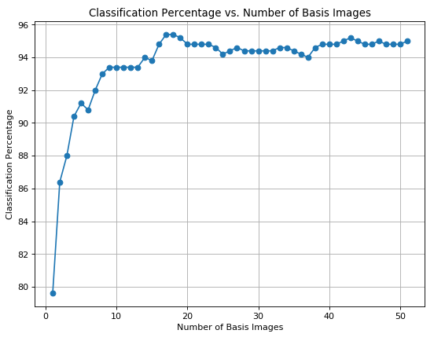

1. 